LAB SETUP
Topics Covered : Ethernet, IP Addresses and Subnetting, CIDR Notation, ARP, ICMP, Switch, Router.
Lab Components :
- Router (2911).
- Switch (2960).
- 2 PCS (PC-PT).
Lab Setup :
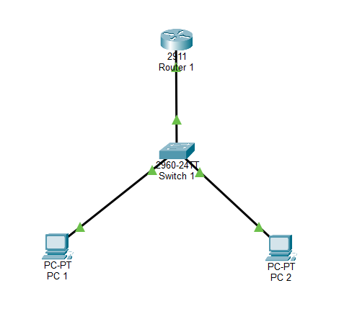
Lab Configuration :
- Drag and drop the lab components.
- Connect
Device A | Interface | Device B | Interface
R1 | GigabitEthernet 0/0 | S1 | GigabitEthernet 0/1
PC1 | FastEthernet 0 | S1 | FastEthernet 0/1
PC2 | FastEthernet 0 | S1 | FastEthernet 0/2
- Click Router 1 -> CLI tab. If prompted to enter the initial configuration dialog, type no and enter the following commands:

enable
configure terminal
hostname R1
interface gigabitEthernet 0/0
ip address 192.168.10.1 255.255.255.0
no shutdown
exit
end
show ip interface brief
- Configure the PCs
For each PC, open Desktop → IP Configuration.
Enter these settings:
Setting | PC1 | PC2
IP address | 192.168.10.11 | 192.168.10.12
Subnet mask | 255.255.255.0 | 255.255.255.0
Default gateway | 192.168.10.1 | 192.168.10.1
- Test Connectivity for each pc.
PC1 -> ping 192.169.10.12, ping 192.168.10.1.
PC2 -> ping 192.168.10.11, ping 192.168.10.1.
Key Concepts :
Our first network uses 192.168.10.0/24.
Network property | Value
Network address | 192.168.10.0
Subnet mask | 255.255.255.0
CIDR prefix | /24
Usable host range | 192.168.10.1–192.168.10.254
Broadcast address | 192.168.10.255
Total IPv4 addresses | 256
Usable host addresses | 254

Why 254 usable addresses?
A /24 leaves 8 bits for host addresses, giving $2^{8}=256$total addresses. The first address identifies the network, and the last is its broadcast address, leaving 254 for hosts.
An IP address identifies a network interface at Layer 3. A MAC address identifies a network interface at Layer 2. The switch forwards Ethernet frames using MAC addresses, while a router forwards IP packets between networks.

The 10 key lessons from Lab 1
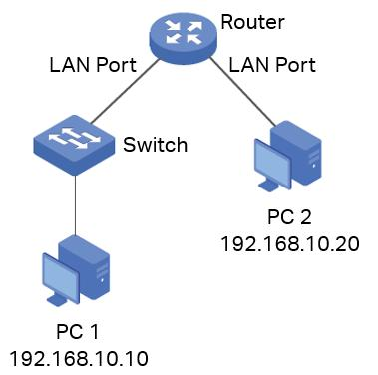
1. Network devices and their roles
- PC: Sends and receives data.
- Switch: Connects devices on a local network.
- Router: Connects different IP networks.
You practiced: Building a network with four devices.
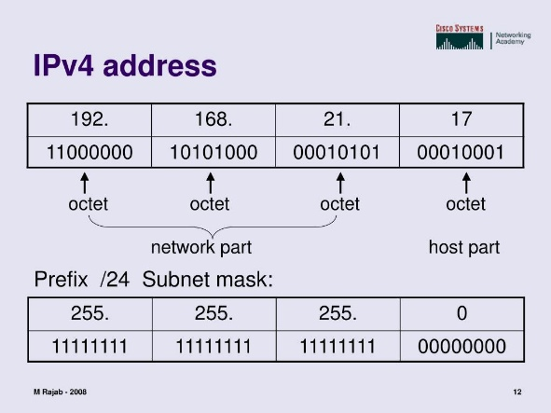
2. IPv4 addressing
You learned that each device needs an appropriate IP address for communication.
Example: 192.168.10.11
An IPv4 address contains 32 bits, represented as four decimal octets.
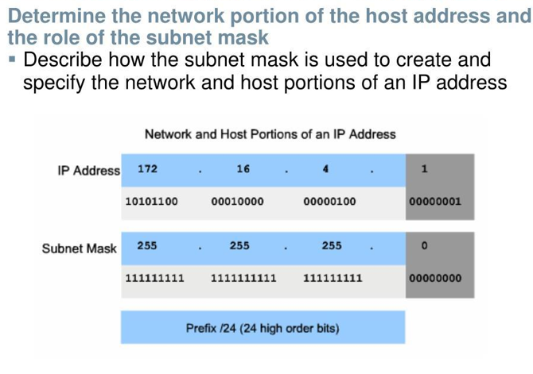
3. Subnet masks and CIDR
You used 255.255.255.0, equivalent to /24.
This means 24 bits identify the network and 8 bits identify the host portion. It gives 254 usable host addresses in a conventional IPv4 /24 subnet.

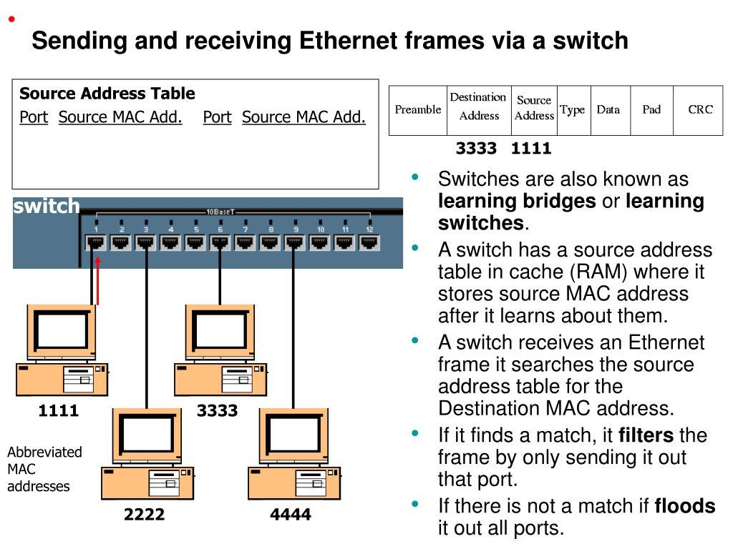
4. MAC addresses and Ethernet switching
Switches learn source MAC addresses and use their MAC address tables to forward Ethernet frames.
IP addresses and MAC addresses serve different purposes at different networking layers.
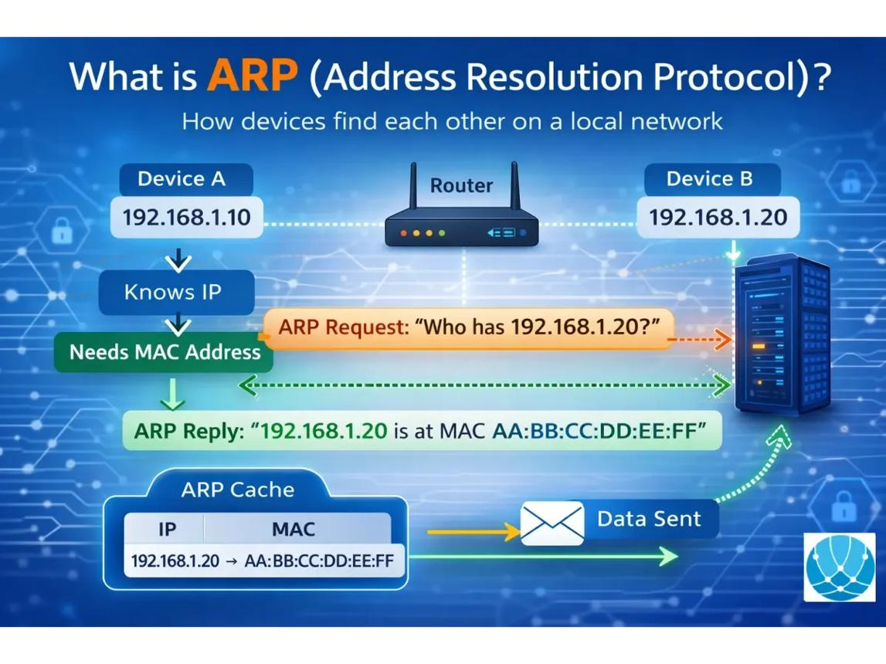
5. ARP — Address Resolution Protocol
ARP helps a device discover the MAC address associated with a local IPv4 address.
You can observe ARP requests and replies in Packet Tracer's Simulation mode.

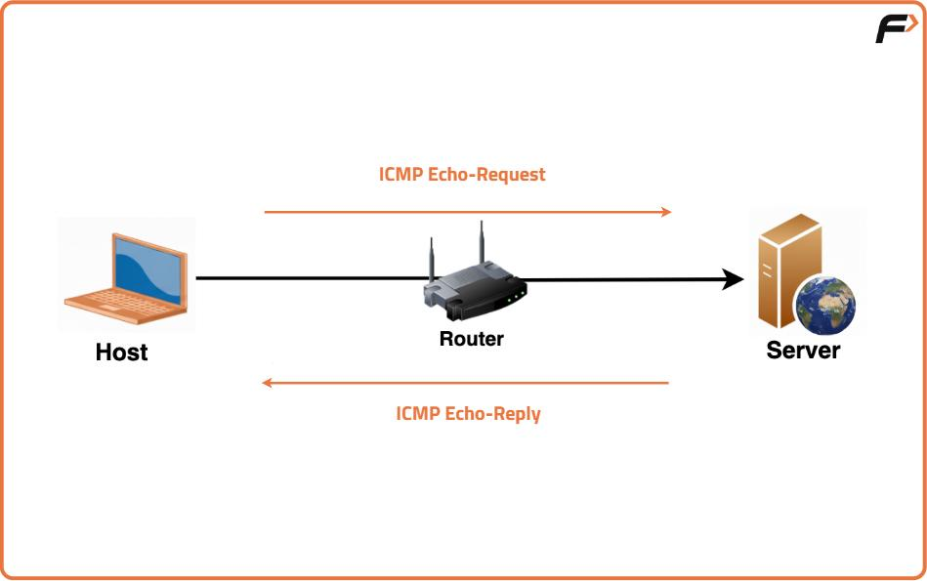
6. ICMP and ping
You used ping to test IP connectivity. Ping sends ICMP Echo Requests and looks for Echo Replies.
A failed ping doesn't always mean the entire network is broken; you need to investigate the cause.
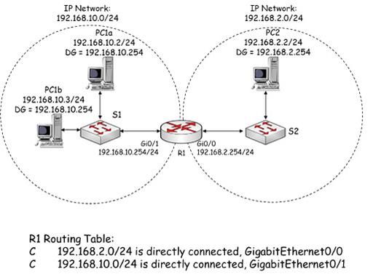
7. Default gateways
You configured 192.168.10.1 as the default gateway.
A host normally sends packets destined for other IP subnets to its default gateway. Hosts on the same subnet generally communicate directly through Layer 2.

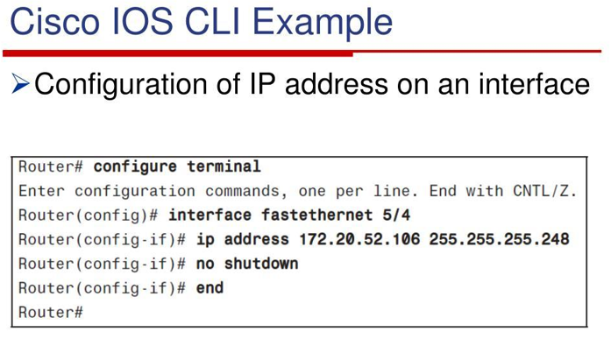
8. Cisco IOS CLI
You practiced enable, configure terminal, interface, ip address, no shutdown, and show ip interface brief.
You also encountered user EXEC, privileged EXEC, global configuration, and interface configuration modes.
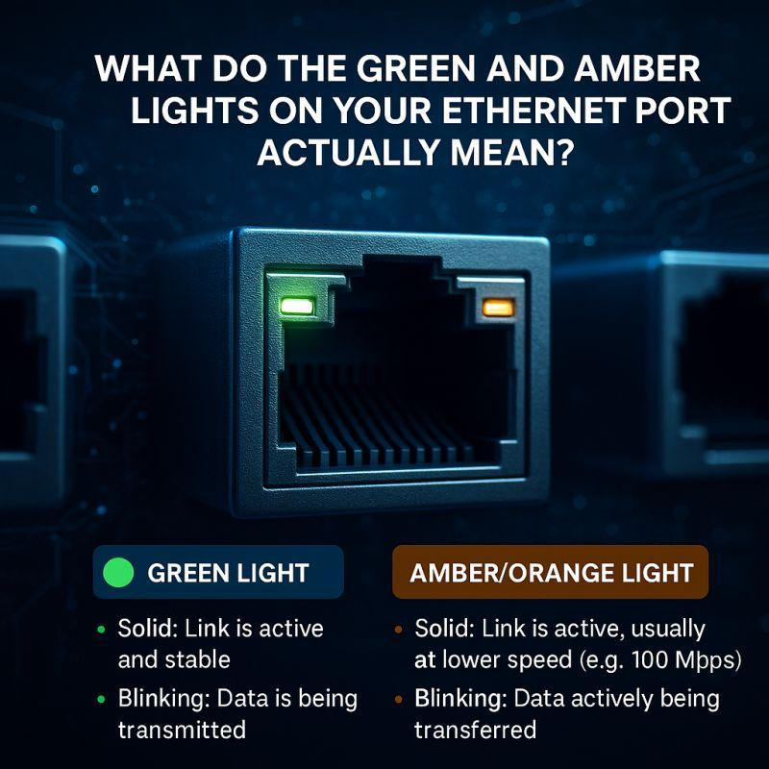
9. Interfaces and link status
You learned to check whether a router interface is enabled and operational.
up/up indicates that both the interface and its line protocol are up. Physical connections, port states, and configuration can all affect connectivity.

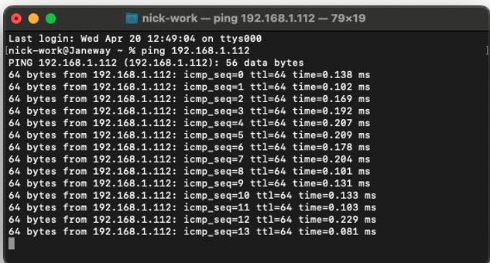
10. Troubleshooting methodology
By changing PC2's IP address and testing again, you learned how a configuration error can disrupt connectivity.
Good troubleshooting checks addressing, subnet masks, interfaces, cables, and routing in a logical order instead of changing settings randomly.
The most important concept to understand
Here is what happens when PC1 pings PC2:
PC1: 192.168.10.11
Checks whether PC2 is in the same subnet
ARP
Discovers PC2's MAC address if needed
Switch S1
Forwards Ethernet frames toward PC2
PC2: 192.168.10.12
Receives the ICMP request and can reply
Notice that the router doesn't need to route this particular communication. Understanding when a router is needed and when it isn't is one of the most important networking fundamentals.
What Lab 1 does not teach you yet
You'll learn these in subsequent labs:
Topic | Planned lab
Network, broadcast, and usable host calculations | Lab 2: Subnetting
Routing between different subnets | Lab 2
VLANs and trunk ports | Lab 3
DHCP and DNS | Lab 4
TCP versus UDP and HTTP | Lab 4
Default routes, NAT/PAT, and ACLs | Lab 5
Check your understanding
Before moving to Lab 2, try answering these three questions without looking back:
- Why can two PCs in the same subnet communicate through a switch without the router routing their packets?
- What is the difference between an IP address and a MAC address?
- If PC1 can ping PC2 but cannot reach a computer on another subnet, what network setting would you check first?
If you can explain those three concepts in your own words, you're ready to begin subnetting and routing in Lab 2.

